Nick Gravagne's Action Geometry Program is once again available with a brand new look and several major upgrades to functionality. November, 2017—NEW VERSION

The NEW “Compare” page simplifies things greatly!

Explained more fully below, but in a nutshell the Compare page asks you to compare Computed Blow Distance (as calculated by the program) to the Mfg. spec. If they are not the same or very close you try out a knuckle or capstan change until they converge.

In the screenshot below, the Computed Blow Distance is 49.2 mm while the Mfg. spec for this Steinway is 45 mm. Also note that the action ratios readouts, the values of which should be close or identical, indicate a spread of 5.0 (the target) --- 5.5 (the action ratio based on action parts measurements) --- 6.0 (the action ratio computed by the program based on other calculated parameters). So, no convergence here either. Again, see below for more details.

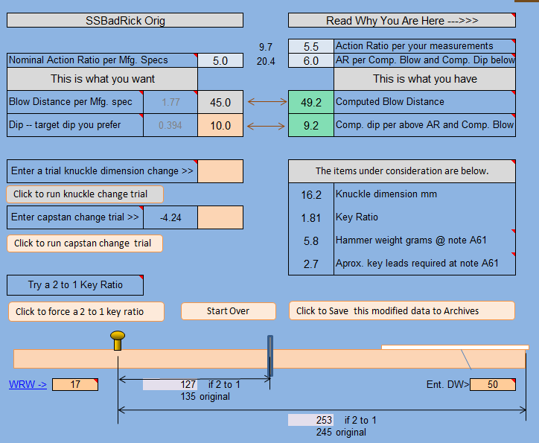

What the Action Geometry Program (AGP) does:

- Generates Action Ratios of a given piano action and / or any proposed changes you are considering making to the parts or layouts.
- Auto-computes all difficult-to-measure action arms (such as the radial shank input arm and the radial whippen output arm) to greatly simplify things for you and increase accuracy.
- Supplies clear, large and colorful drawings for easy reference as to how to layout and measure the action components of key, whippen, and shank.
- Supplies you with a much expanded "Compare..." page that allows you try out different configurations of the action components such as,
- "What would happen if I change the capstan position?"
- "What if I change the knuckle distance from 15.5mm to 17mm?"
- "I am thinking of getting a new keyboard with a different key ratio."
- "What happens if I change the action spread?"
- Dimensional changes made or proposed to any action parts will impact and distribute through the system as a whole. The program takes care of these sometimes subtle changes in the background for you.
- Yields a Reflected Inertia value.
- Tells you how many leads will be required in the key sticks based on the original data entered on the Compare page or per any changes you try out on there.
- Relates certain data and computations in Stanwood Balance Weight terms as well as customary Downweight terms.
- And much more! Read below and see many screenshots of the program.

Platforms for use

Due to the enormous capability of the MS Excel spreadsheet, the new program requires that you have MS Excel spreadsheet installed on your computer. Known workable versions include Excel 2003 and later, but may work in earlier versions of Excel. You see, the Excel program runs a multitude of sub routines (called Macros in MS-speak) behind the scenes in order to automate the many interconnected computations across the workbook.

If you are a Mac user, you somehow need to be able to run Excel and all macros. Current users report that the installation and use of Parallels Desktop allows the use of Win XP, 7 and 8 to run on Macs. Also, if you have Mac office 2004 or 2011 or 365 the Excel file will run, but Mac office 2008 is problematic and doesn't like to run the background macros. Perhaps obtain a cheap PC Windows running XL OS.

Pricing

Skip the pricing for now; I want to first read about program functionality

Two versions of the Action Geometry Program (AGP) are available

1) The AGPL, the basic or light version. Though this version does not contain all the worksheets and functionality of the full version it is nonetheless very powerful and does include all pertinent action ratios, key leading per note and inertia values. In addition the program supplies you with a suggested maximum hammer weight column (range from note 1 to 88) which will work with the particular action configuration you are evaluating.

Price for the AGPL is $95 for one computer and $25 for each additional computer.

This light version contains a tab worksheet called UPGRADE. If you would like to upgrade to the full version AGP, and after making payment of an additional $55, instructions will be supplied to you to access and click on the Upgrade button. The full version will then appear.

Note that, although many of the screenshots below relate to the AGPL, some relate only to the full AGP version.

2) The AGP. This full version contains everything the light version has but much more. This version is particularly useful to those technicians who are more comfortable working with protocols such as Balance Weight and Front Weight. In any case, the full version is more educational as well.

Price for the AGP is $150 for one computer, and $25 more for each additional computer.

Note that if you are a past user of any of our Action Geometry Programs from several years ago (i.e. those old versions did not require the Excel program to run and cost $75) you are allowed a full credit toward the AGP Full program meaning your cost would be $75 for the AGP Full Program.

Price for AGP is $75 for past users of the old program and $25 for each additional computer. Or $45 for the AGPL.

If you wish to purchase the program go to www.gravagne.com where you will find a “BUY NOW” Button. You will also find a dropdown window there listing six purchase options.

- AGP Full Program ---- $150
- AGPL Basic Program ---- 95
- Basic to Full Upgrade* ---- 55
- Renner Grad Upgrade** ---- 75
- Past User Full Program ---- 75
- Past User Basic Program ---- 45

* Upgrade option only available if you are currently running the Basic Program
** Renner Academy grads receive a complimentary AGPL program with Academy attendance, so this option is for RA grads who wish to upgrade to the full program.

At the Gravagne web site, clicking on the Buy button will direct you to the PayPal site where you can pay via PayPal (if you have an account --- signing up is free) or by using your credit card. Look for the credit card link there. When payment has cleared we will either email the program to you or else direct you to a download link. Should you inadvertently choose the wrong purchase option (e.g. Renner Grad Upgrade when you meant to choose something else) we might catch this at our end or you can notify us and we can work it out together.

You may also call in with a credit card number or send a check to:
Nick Gravagne
5235 N Strawberry Lane
Strawberry, AZ 85544

Trying Out the Program

If you wish to try out the program first, we understand. Send us an email with your request and we will send out the full program which will work for two weeks. After the time period is up the program will ask for an activation code. Should you decide to purchase we will supply you with the activation code.

Your request for a trial program or an outright purchase will be held in strict confidence. You will not be hounded or contacted in any way unless we are sending out a group email pertaining to any new information we may have that we deem you would likely be interested in relating to the program.

If you have purchased the program or simply tried it out and wish to make comments or suggestions, these would be very much appreciated but not expected and we will not follow up on any purchase or trial unless we hear from you.

*************************************************.

OK --- on to some of the useful functionality and screenshots.

Note that current version of the program (AGPcomp1117) has been simplified as to use and visual impact and has been updated and revised in a myriad of ways. Therefore screenshots below and some of the descriptions herein will have been noticeably altered from the current program you may have on your computer.

THE ARCHIVES PAGE

As of this writing the primary pages of input and first analysis are the Archives page (where you enter all original data as measured from the action parts) and the Compare page (where the data is compared to a manufacturer’s implied standard 5 to 1 action ratio).

See the screenshot of the Archives page below. This page serves only two purposes: 1) to enter data; 2) to save data. This is where you enter your measurements for the key, whippen and shank. Click on Links (such as Key Output Arm) in order to view details on how to measure. Note that you may enter data only in the tan boxes (cells).

Use the grid block (ENTRY AND / OR OUTGOING DATA) to enter your measurements. The gray boxes are auto-calculated, so no need to enter data there. Be sure to enter the name of the piano in the blue heading box (e.g. where it reads “SSBadRick ORig”). Note that entered data will include regulation specs such as Mfg. blow distance, letoff and aftertouch. The spec for dip will be later entered on the Compare page.

After data has been carefully entered and double checked, click on the blue box (button) which reads "Click here to export...” You will be taken to the Compare page (explained below). Usually your action data will be modified at the Compare page per a knuckle location change or a capstan change. Such modifications will alter your original data. You will want to retain both your original data as well as any modifications as two separate grid blocks. Saving and retrieving data is done here on the Archives page.

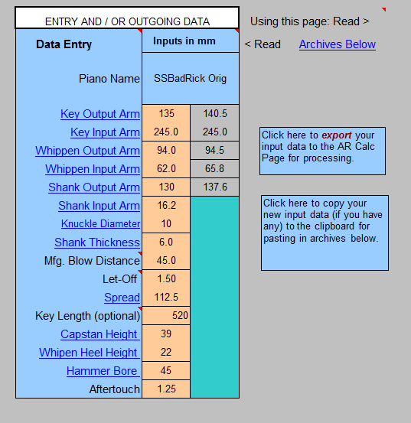

*******************************************************************.
Continued below…

NEW --- THE COMPARE PAGE

Note the Compare page in the screenshot below. There are two sides to it:

Left side reads “This is what you want”
Right side reads “This is what you have”

The Mfg. spec for Blow distance has been copied here per your entry on the Archives page. Check the Piano Action Handbook for this. Steinway's spec is 44.5 mm, but 46 mm is kind of a standard. Note that 10 mm has been entered here for Dip but you might enter 10.2 for Young Chang, etc.

Now find the green box showing a 49.2 mm Computed Blow Distance. This is the Blow distance that satisfies the measurements you made of the action parts. If the Blow is higher than the Mfg. spec to the left (as is the case here), then try entering a larger knuckle location dimension in the "Enter a trial knuckle…" tan box.

If the Blow is lower than the Mfg .spec to the left, then try entering a shorter knuckle location dimension in the "Enter a trial knuckle…" tan box.

The screenshot after this one shows the result of entering a trial 17 mm knuckle dimension to replace the original 16.2 mm location.

Note above that the action ratios readouts, the values of which should be close or identical, indicate a spread of 5.0 (the target) --- 5.5 (the action ratio based on action parts measurements) --- 6.0 (the action ratio computed by the program based on other calculated parameters). So, no convergence here.

Below note that the 17 mm knuckle change has brought the Computed Blow closer to the Mfg. Blow and that the action ratios are also converging.

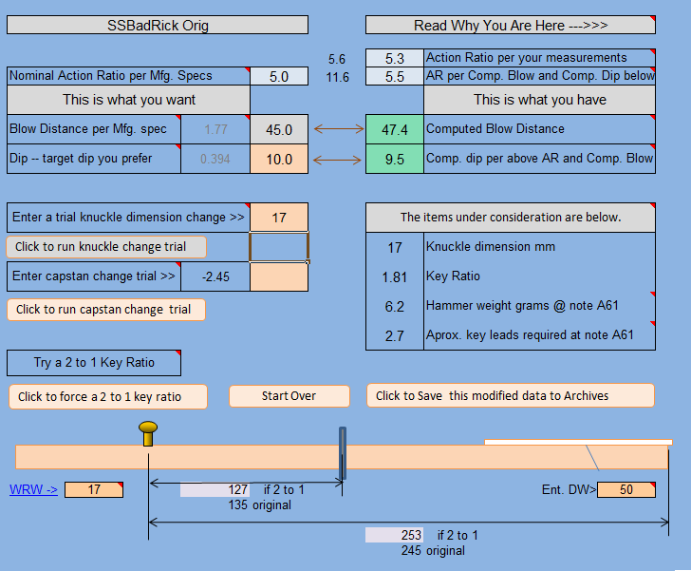

But there is more to go for this action. Find the little number to the right of the box which says “Enter capstan change trial >>”. The number is a negative -2.45 indicating that the capstan screw needs to be relocated about 2.5 mm toward the balance pin. So let’s enter that number and then see the following screenshot for results.

With this final capstan change we see that the action ratios have converged at 5.0 and the Blow and Dip numbers have as well. So, modifications to the SSB action (which originally was quite bad) include changing the original 16.2 mm knuckle location to a 17 mm one, and moving the capstan by 2.5 mm toward the balance pin.

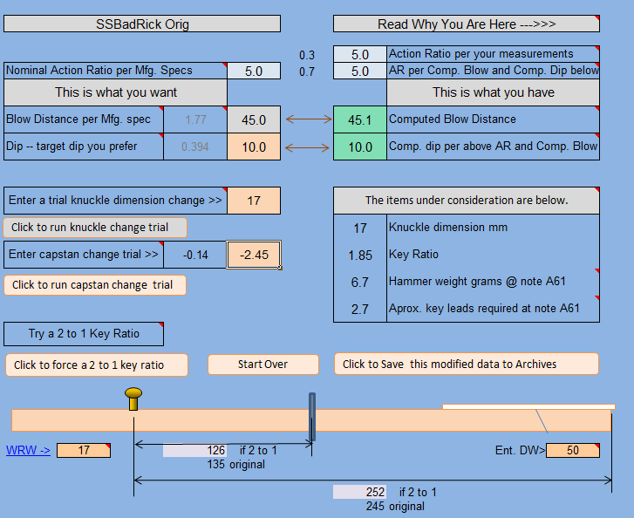

*******************************************************************************.
Continued below…

THE HAMMERS PAGE

Below is the Hammers Page, a very significant feature of any version of the AGP. It is here where you can view the full range of theoretical program-generated hammer weights which dovetail and are “happy” with the action ratios you either find in an exiting setup or else change for an action overhaul.

You will note on this page that two comparison readout columns are used for analytical purposes: the My Weights (My Wts) and the Original Weight (Orig. Wts.). A quick look at the graph of these three columns of data will instantly reveal the capability of the action ratios to support the original hammer weights and your proposed replacement weights to that of the program-generated weights, which are considered a maximum ceiling for hammer weights.

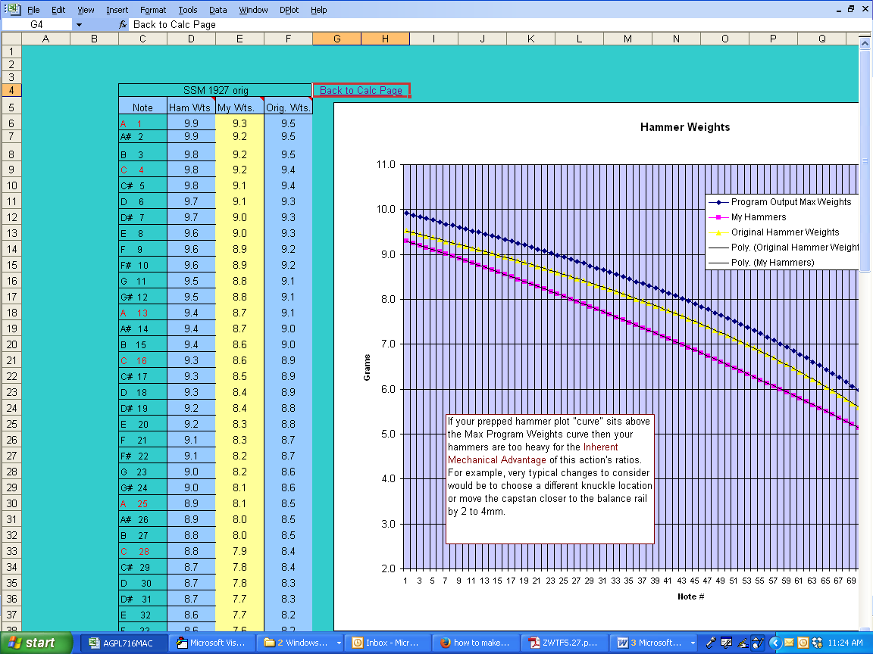

*******************************************************************************.
Continued below…
THE SUMMARY PAGE

An additional page called the Summary Page is shown below. This catch-all page gathers, summarizes and organizes in readout fashion several useful program parameters.

- Action Ratios
- Strikeweights and hammer head weights for all notes in the scale
- Inertia and estimated required Key Leads for all notes
- A program-generated maximum hammer weights column for all 88 hammers
- Declining inertia values and Key Leads for all 88 notes

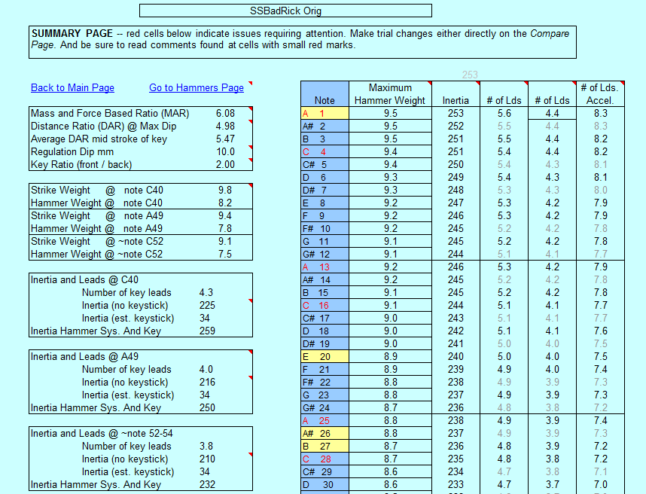

Most of your work will take place on the Compare page, the Archives page, the Hammer page and the Summary Page (and / or Key Leads Page depending on your version).

****************************************************************************.
Continued below…

THE SIMPLE AR CALCULATOR PAGE

The Delta Δ Readouts (available with Full Program only but not critical to have) found at the Simple AR Calculator page.

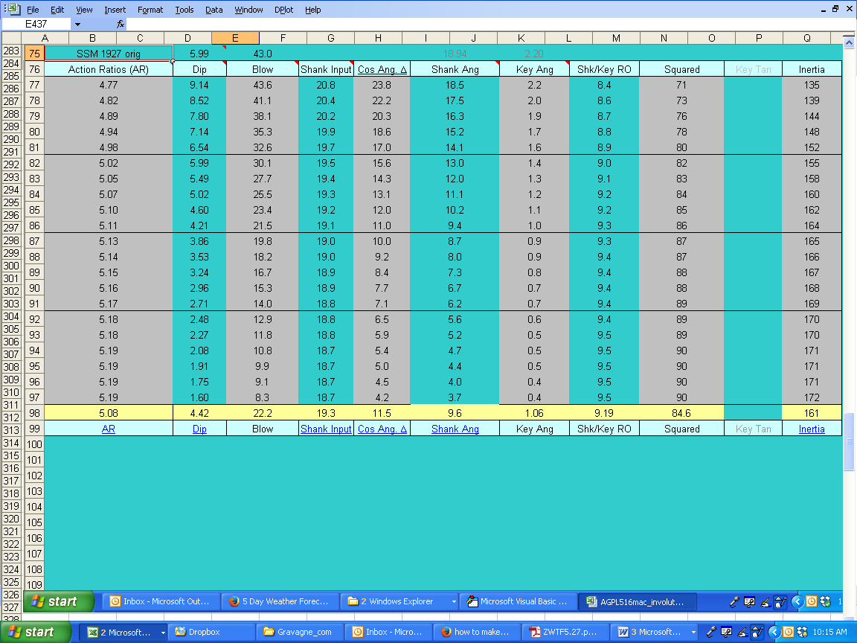

Delta (symbol Δ) signifies a changing variable in the world of mathematics. The Delta Box above shows how several functions change throughout the keystroke. Thus delta functions include a changing Action Ratio, a cosine angle change at the knuckle and repetition lever, a System Inertia change, a relative Dip change and so forth. Awareness of these changes is interesting, of course, but not required to setting up a good action rebuild.

These data are displayed in graphic form at the Graphs page at the bottom of the worksheets and included for your interest and as a learning tool. A full grasp of the significance of these data and related graphs is not necessary to evaluate a grand piano action at its most basic level. The Simple AR Calculator page and the Graphs page is only available with the full AGP program.

The Touchweight Perspective Box found on the Simple AR Calculator page

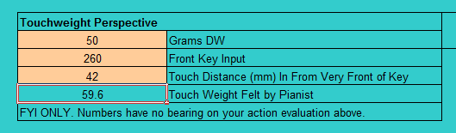

Pianists place their fingers well inside the very ends of the keys. This box accepts three inputs: Grams DW (50 gms is default); Front Key Input (distance from balance pin to the very front edge of the key); and a Touch Distance located in from the very front of the key where a pianist might place a finger. The box above taken as a snapshot shows that although the DW is 50 grams, when the pianist activates the key at 42 mm (about 1 and 2/3rds inches) in from the key end, the touchweight / DW feels like 59.6 grams rather than 50. This surprising fact should remind us of the remarkable adaptability of the pianist to accept this gross difference in touch as well as to balance and moderate our thinking as to what level of perfection in our work is realistic.

**********************************************************************************.

Continued below…

THE ARCHIVES PAGE IS WHERE YOU SAVE DATA

Note that several actions are saved and provided with the program. Many, though not all, represent well setup and functioning actions. Copy and paste them into the Data Entry grid, export them to the Compare page for processing; study as a learning tool as well as a sort of touchstone as to what works and looks good. Try not to alter the bundled-in saved data so much to the point where you cannot recall the original data.

The SSBadRickOrig (or Steinway B bad) data indicates a problematic action. Plug in the data and see what happens. Run through some trials to see what kind of improvement you might make.

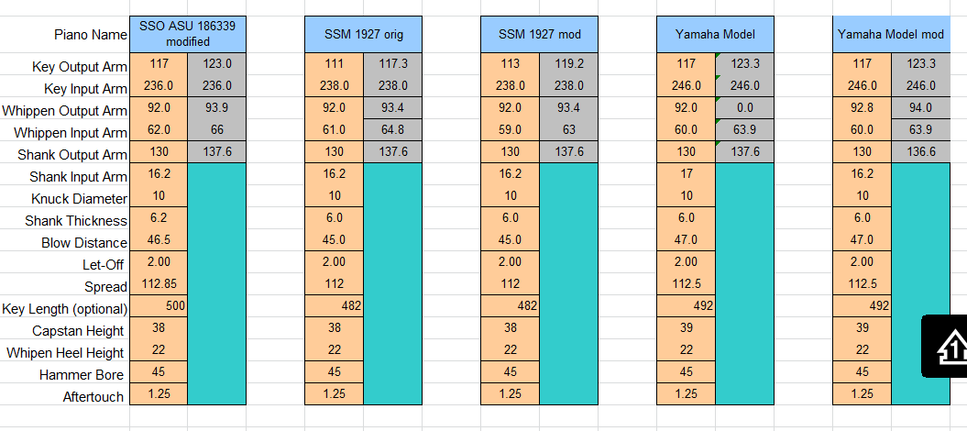
***************************************************************************.

THE KEY LEADS PAGE

The Key Leads worksheet is one of my favorites and the next set of screenshots detail some of the functions it carries out. The top of the worksheet includes introductory remarks so you can read them there. The Key Leads page is only available with the full AGP program and is not required to accomplish a fine action evaluation and redesign. It is, however, very educational.

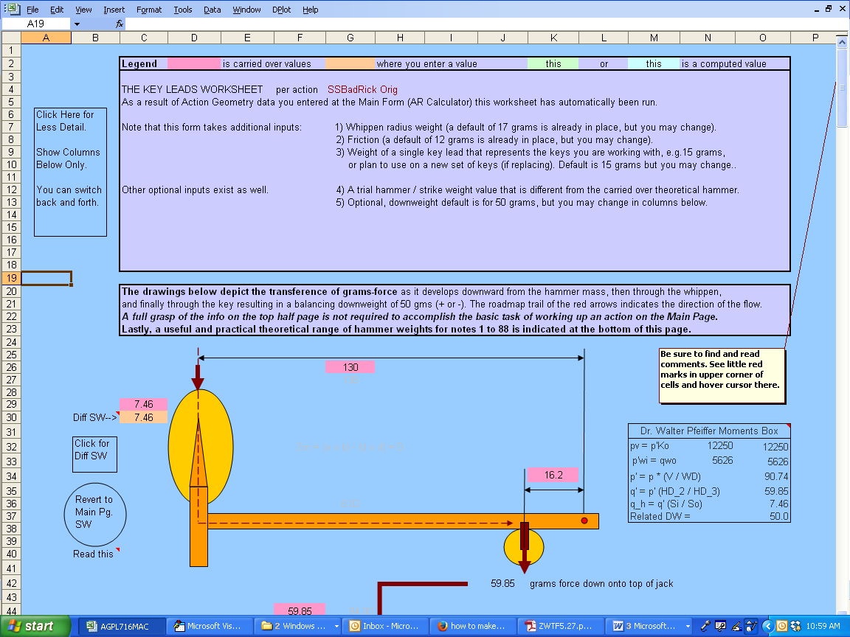

The Key Leads Page continues below in the following two screenshots where you can see the hammer and shank along with a whippen. What is being depicted here is a transference of grams-force as it develops downward from the hammer mass (Strikeweight), then through the whippen, and finally through the key resulting in a balancing downweight of 50 grams (+ or -). Follow the red arrow and line. The data working its way from hammer tip to key end is automatic and is generated from the simple data you entered on the Archives Page.

Continued below…

Key Leads Pages continued.

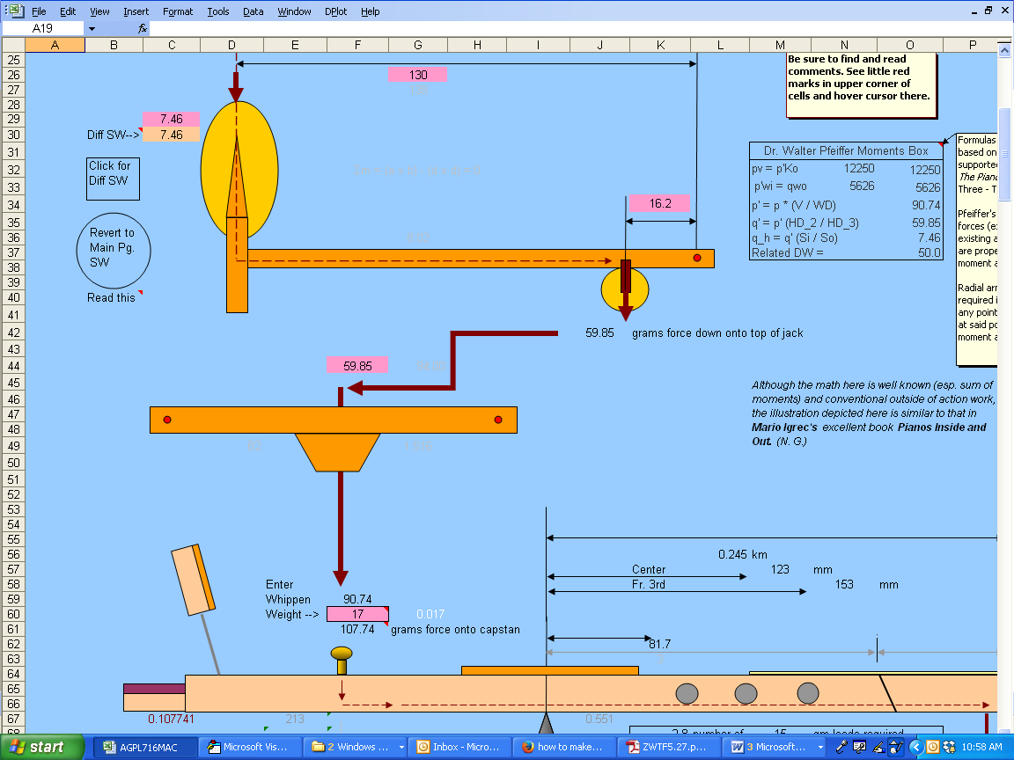

Continued below…

Key Leads page continued.

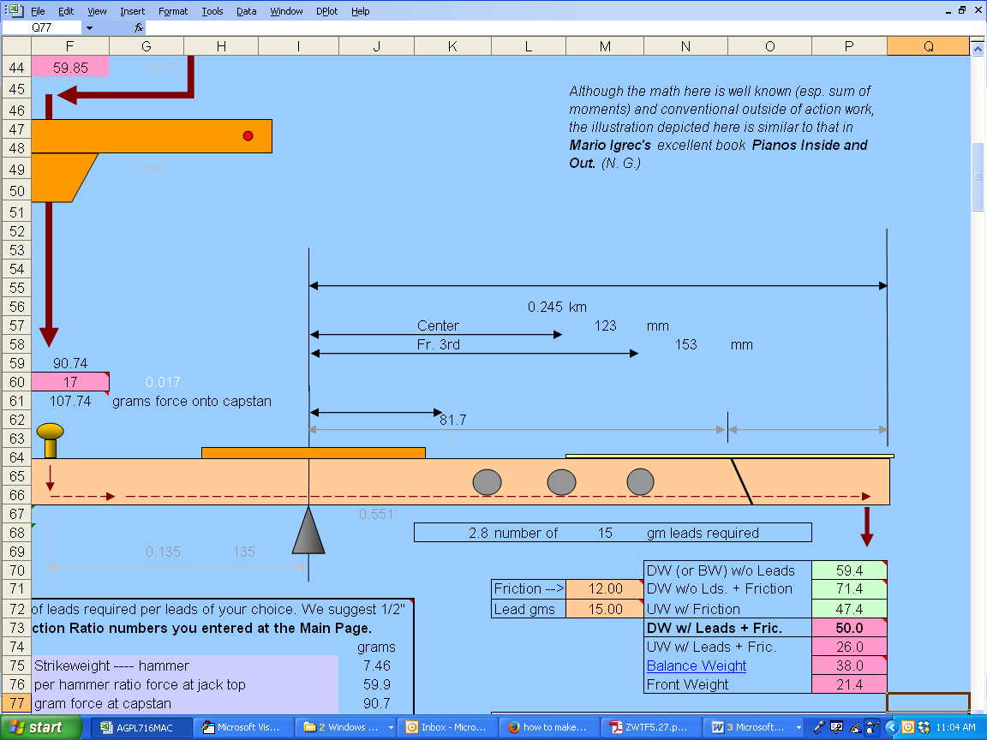

Note that as interesting as these interconnecting relationships are, grasping their full meaning is not essential in generating useful action analysis on the Archives Page.

And we are not done with the Key Leads Page. Below is an extensive readout of generated data as it relates to the simple inputs you made at the Archives page. Note the columns headed "Note", “DW Tar." (Downweight target), "BW" (balance weight), "SW" (Strikeweight), "Hammer" (weight in grams), "Inertia", "# of Lds" (number of leads required) for two possible positions in the front key segment. You can set the DW Target yourself either as 50 grams constant or to a descending DW as you see below (recommended btw).

Focusing on the Hammer Column you will find the little read mark indicating the existence of a comment which reads:

Theoretical hammer weight (mass) suggested. Consider these values as a guide to steer you in a consistent direction. Note that the hammer value = the SW less estimated shank SS of 1.6 gms.

As with the Concert Keys WS, this Hammer weights column is based on arbitrary (but well considered) proportions of the frontweight ceiling as proposed by David Stanwood. In any case, consider the values in a relative way in your work.

Understand it this way: whether or not you made changes to the action ratio or component configurations in any way, then this range of hammer weight replacements is more or less indicated.

Also, if the action ratio and other parameters from the Compare page are acceptable (either as is or due to changes you have made) you may consider the hammer weight scale as maximum weights for your choice of hammer weights, or at least a guide for relative purposes.

For your convenience data generated in these columns is automatically generated with any action data you enter at the Archives Page or any changes you are trying out at the "Compare..." page.

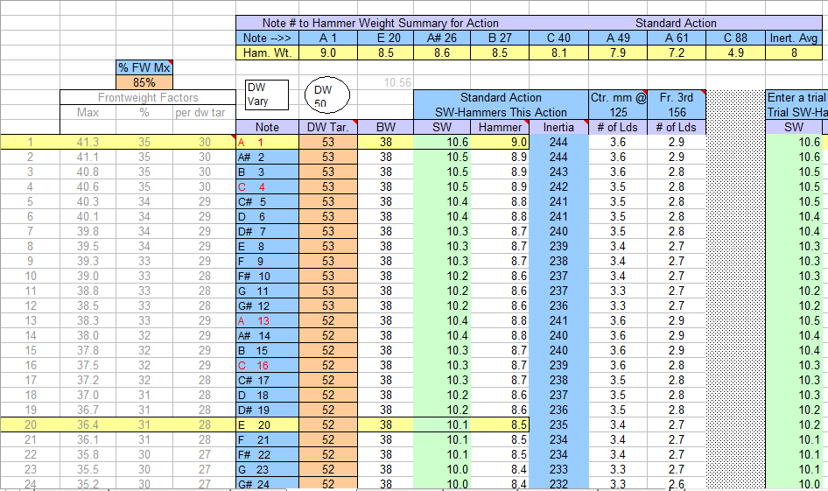

*****************************************************************************.
Continued below…

THE KEY INERTIA PAGE

Now on to the Key Inertia page (following two screenshots available only with full AGP program). Working through this page is more of a learning thing than something absolutely required to workup a decent action on the Compare Page. The instructions on the page explain what to do and what is happening here, but in broad strokes you can enter the required data, such as locations of leads in an existing key stick, and the program will generate the inertia of that keystick.

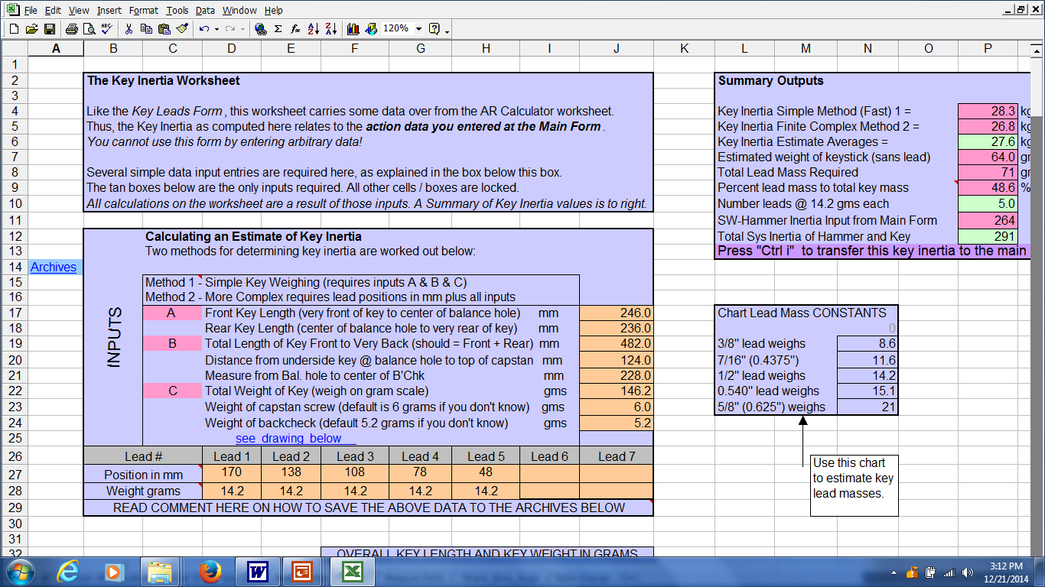

**********************************************************************************.
Continued below…

Key Inertia Page continued showing measurements to the Key Leads, to the center of the backcheck and to the top of the capstan screw.

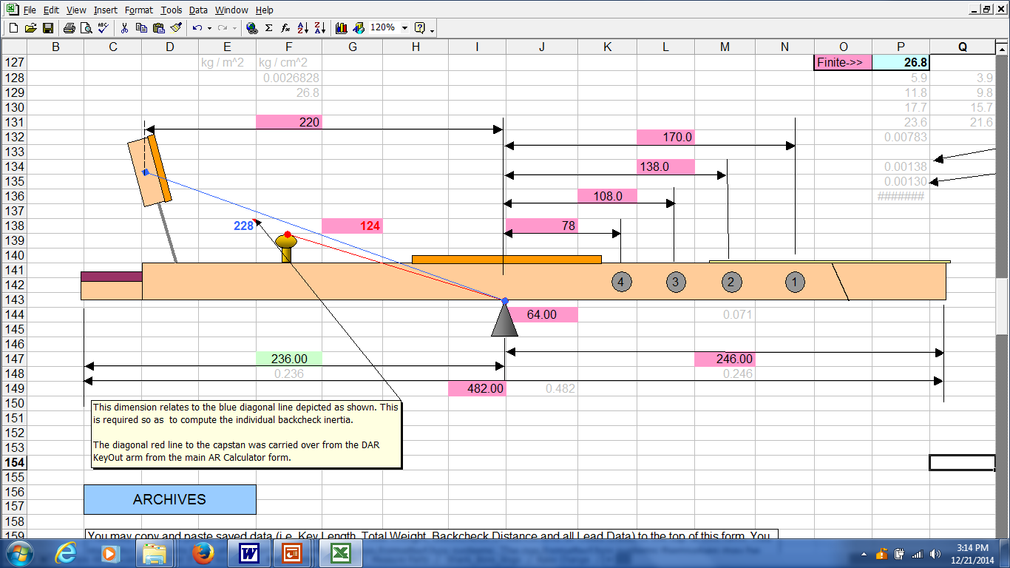

**********************************************************************************.

Continued below…

THE GRAPHS PAGE

I'm a big fan of graphical representations of data, and I bet you are, too; and this is one of the reasons that we chose a spreadsheet format such as Excel to create this new Action Geometry Program. So, I've included several charts and graphs depicting all sorts of data. Below shows one such graph of plotted data of changing blow distance as it relates to dip and an ever-changing and declining function of Action Ratios. The Graphs page is only available with full AGP program.

*******************************************************************************.

Continued below…

THE SHANK-BORE PAGE

Below is a screenshot and visual as it relates to the Hammer Bore equation. Use this page to compute the hammer bore by plugging in appropriate numbers in the tan boxes. In the case below we find a string height of 197 mm and hammer flange center height of 147 mm which together yield a hammer bore length of 50 mm.

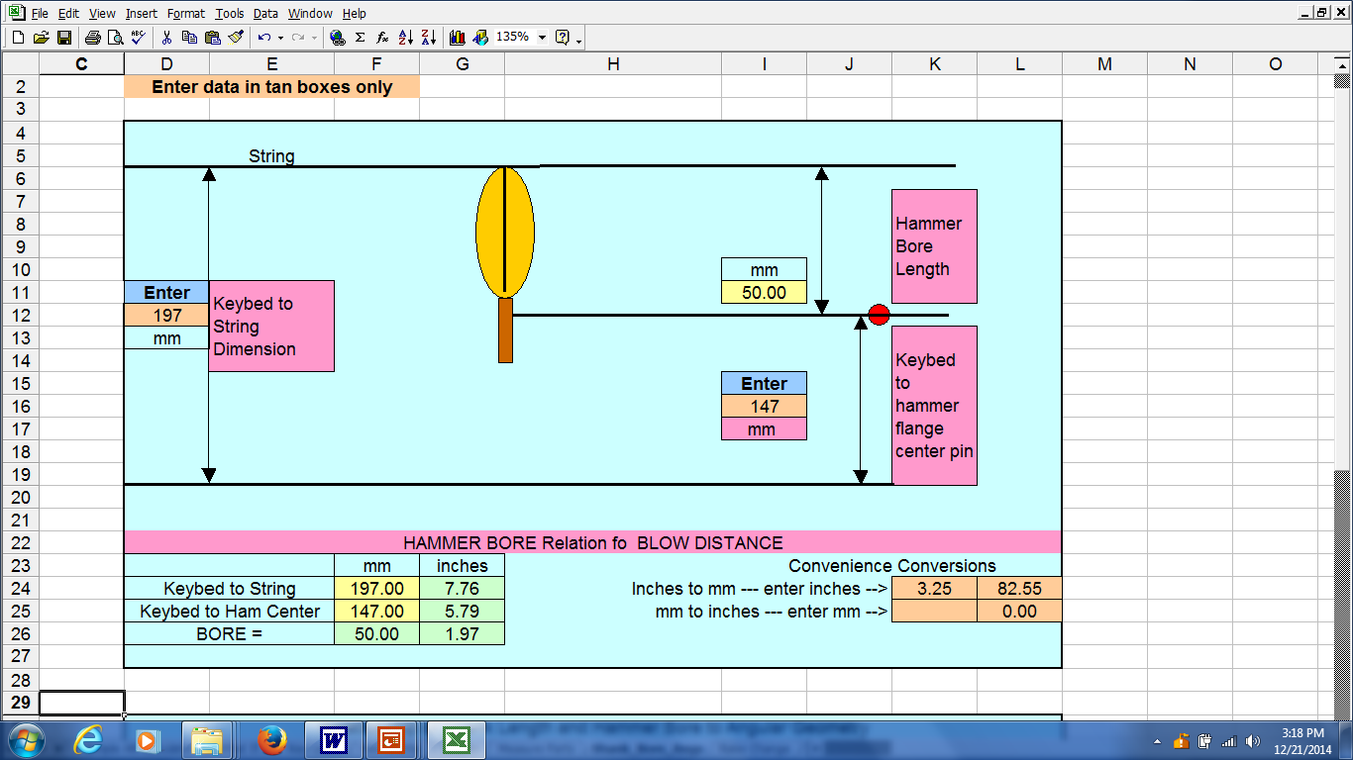

*********************************************************************************.

Continued below…

THE RAKE CHANGE PAGE

For those of you who find it convenient and / or necessary to bore the hammers at 91 degrees rather than 90 degrees, this page is for you. Following the plan below will allow the shank to be elevated above the cushion by a few mm while at the same time allow for the hammer crown to strike the string squarely. This configuration is sometimes required or convenient, but is an advanced concept that will demand your full attention. Be sure to measure the angles of the existing hammers, particularly on a factory job, to see how they were hung. A 91 degree rake may be called for in order for things to work out best. In the configuration below we see that a 43.7 mm bore dimension is called out and relates to a 91 degree bore angle.

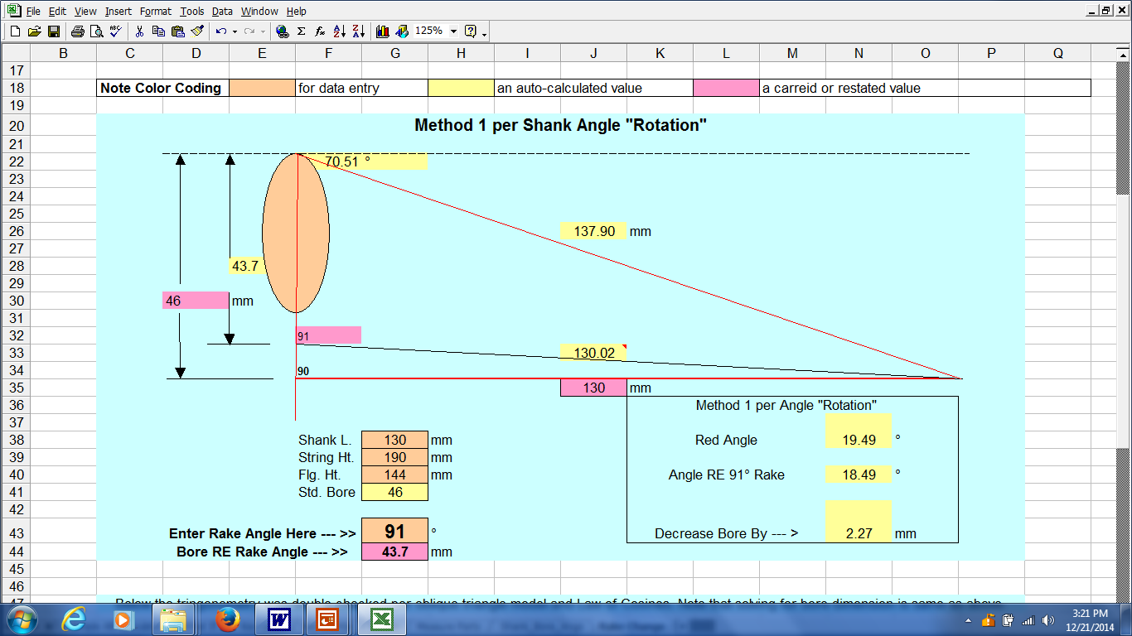

*******************************************************************************.

Continued below…

THE MEASURE PARTS PAGE

Screenshot below shows one of the many drawings you will find in the program. This one is of the hammer and shank and details how the various dimensions are to be measured. Note that the small red dotted dimension (the Shank Radial Input Arm) does not require your measurement as it is auto-computed by the program.

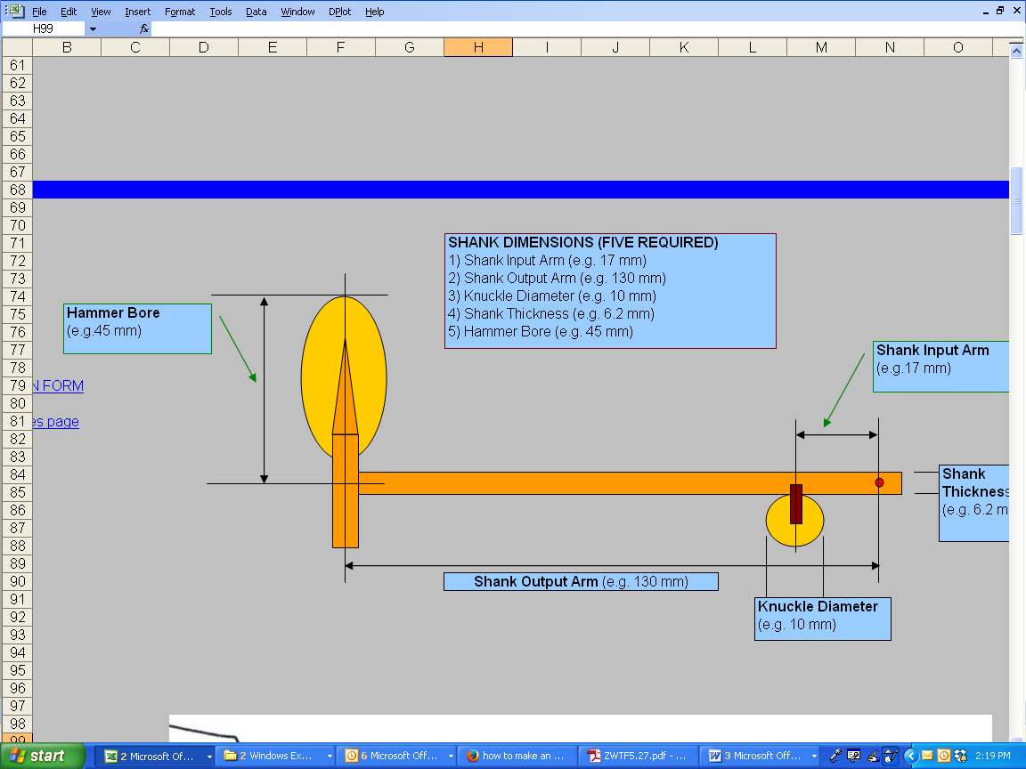

AND THERE’S MORE!

Well, that's it for now. As you can see the program is jam packed with useful and educational functionality! Why not try out the program to see if you like it, and would find it useful.

In any case,

Kind Regards and thanks for viewing the material.

Nick Gravagne
November 6, 2017
Email gravagnegang@att.net

